**Guerilla Art Research**

**What is Guerilla Art?**

Guerilla art is a way of making art which is defined by leaving anonymous art in public places. The art form values freedom and anonymity of the author, letting the artist place works of creativity wherever they would like. The purpose of these artworks is widely varied, with some artists wanting to make a statement, comment on society, or just doing it for fun. Guerilla artists will often place art in unauthorized areas—this could be vandalizing a secure facility or simply

Possible ideas for guerilla art include sidewalk chalk, sticker art, graffiti, journals, flyers, and many more.

**Impact of Guerilla Art: The Guerilla Girls**

Guerilla art can have a profound impact on society, advocating for the artists’ beliefs or spreading an important message to a wide audience. One movement of guerilla artists is called “The Guerilla Girls”, and they used their art to combat sexism and racism within the art world. I will be using this movement as a case study into the impact that guerilla artists can have.

The Guerilla Girls were a punk radical feminist group which questioned which voices were being heard in the art community. They realized that only a few artists were being represented in museums and the mainstream public, and they aimed to change that, allowing many more voices to be heard. Primarily, The Guerilla Girls wanted to increase the representation of women in art galleries and collections.

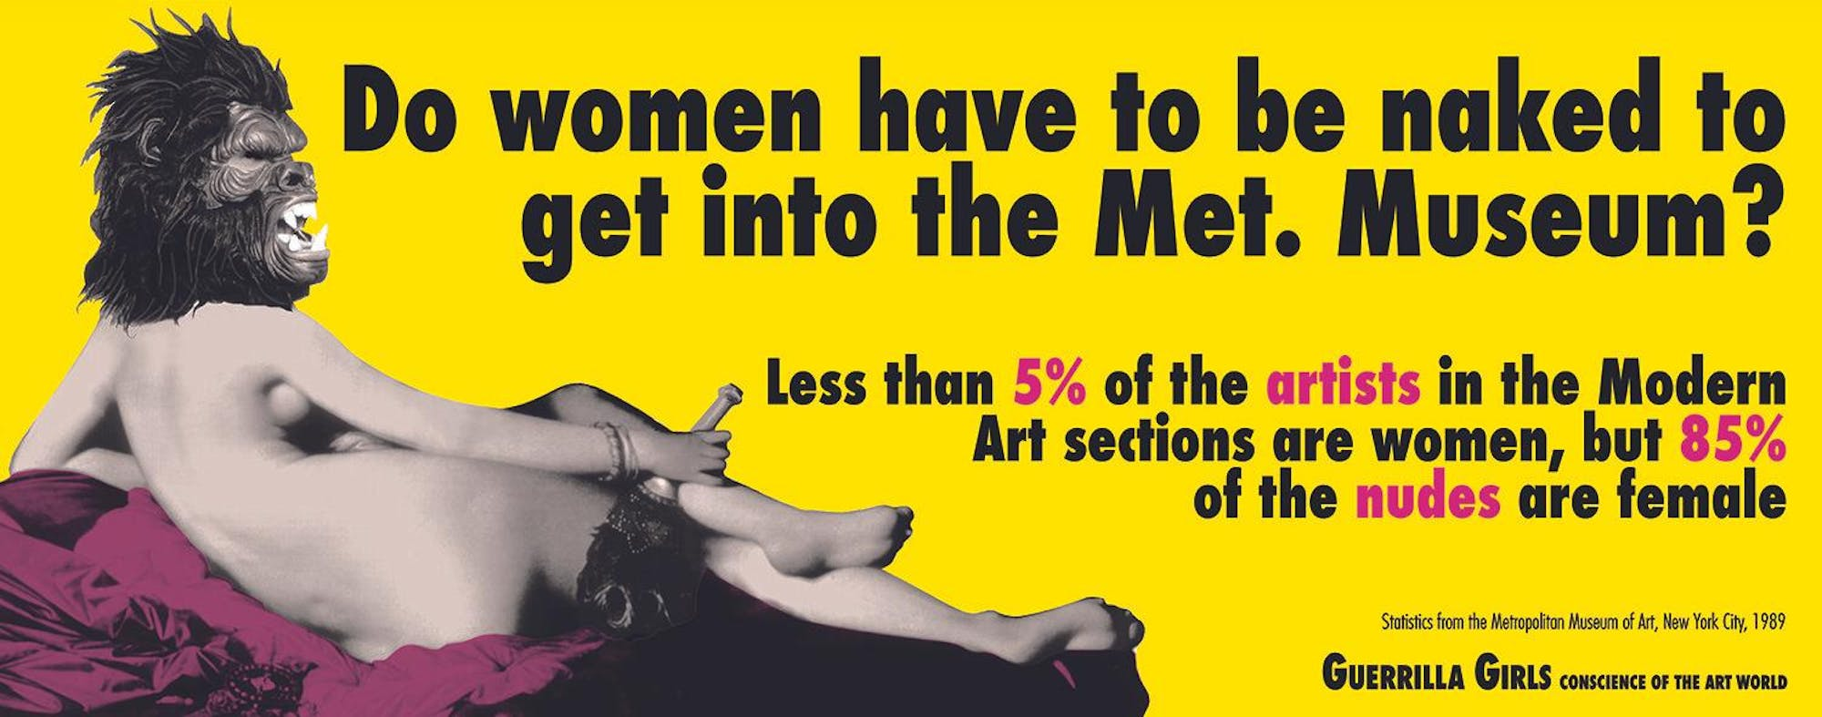The Guerilla Girls made many political posters, graffiti art, and letters to art collections criticizing the underrepresentation of women. Members wore gorilla masks both to hide their identity and utilize wordplay on the name of their group. Below is an example of one of their art pieces.

Guerilla art is sometimes described as art that is meant to shock the viewer, and this art piece is an example of that. Nudity in public often has a shock factor, and The Guerilla Girls used this to their advantage. Combined with the logos of information outlining underrepresentation of women, the artists successfully highlighted the sexist practices of many museums. This art piece also touches on topics outside the art community, criticizing the sexualization and underrepresentation of women in politics and the workplace. The Guerilla Girls continue to use their art to advocate for their cause.

**Ethical Analysis of Guerilla Art: Kant and Scruton**

There are many ethical considerations of guerilla art, most of which relate to whether it is ethical to vandalize property to display art. I will be discussing these questions with reference to the ideas of Immanual Kant and Roger Scruton.

**Kant**

In Kant’s eyes, guerilla art is unethical, because it goes against universal laws, and guerilla art itself cannot become universal law. Yes, guerilla art aligns with the universal law of freedom of expression and the need to communicate one’s beliefs, but it goes against the universal law of respect for others, which includes their property. The act of vandalism is disrespect towards the owner of the property being vandalized.

**Scruton**

Scruton’s perspective is that art should be beautiful, and beauty is the ultimate purpose of art. Therefore, guerilla art fundamentally disagrees with Scruton’s perspective. Guerilla art’s purpose is not to be beautiful, but to send a message and make change in society. Although there are many guerilla art pieces that are beautiful, beauty is not their purpose, and ugliness does not make the art meaningless. Additionally, beauty can be subjective, and some pieces of art are beautiful in the context they are placed in. One artist who is skilled at this is known as Banksy, who paints murals with important messages on public buildings. These artworks are beautiful when placed in that background, but can be seen as ordinary elsewhere. Below is one example.

**What is Art Reading**

In relation to the What is Art reading we did in class, guerilla art is an example of how art has changed throughout history. The emphasis on beauty has faded significantly, and art has become much more inclusive. In the past, graffiti art on city walls would have almost never been considered art. However, today, graffiti is one of the most common forms of guerilla art, and they contain important messages. Guerilla art represents the shifting of art throughout history.

**Resources**

Akdeniz, Mirza. “Roger Scruton - Why Beauty Matters (2009).” *Vimeo*, 23 May 2024, vimeo.com/549715999.

Banksy. *Banksy*, www.banksy.co.uk/out.html. Accessed 23 May 2024.

Raven-Ellison, Daniel. “11 Guerrilla Street Art Greats.” *Travel*, 20 Sept. 2012, www.nationalgeographic.com/travel/article/11-guerrilla-street-art-greats.

Smith, Keri. “How to Be a Guerilla Artist " Keri Smith.” *Keri Smith*, 8 June 2010, www.kerismith.com/popular-posts/how-to-be-a-guerilla-artist-2/.

Sullivan, Grace. “The Guerrilla Girls: Bias, Discrimination and Activism in the Art World.” *The Guerrilla Girls: Bias, Discrimination and Activism in the Art World - The Observer*, 26 Feb. 2024, www.ndsmcobserver.com/article/2024/02/the-guerrilla-girls-bias-discrimination-and-activism-in-the-art-world.